Tornedale Infant Academy



FIRE EVACUATION PROCEDURES

VERSION | AUTHOR | SUMMARY OF CHANGES | DATE PUBLISHED | DATE OF REVIEW
1.0 | AJB | New policy format | September 2025 | September 2026

Table of Contents
1. INTRODUCTION 3
2. INITIAL IMPLEMENTATION 3
3. IN THE EVENT OF A FIRE ALARM SOUNDING 3
4. ROLES AND RESPONSIBILITIES 3
5. FIRE DRILLS 4
6. FIRE PROCEDURES FOR LUNCHTIME 5
7. FIRE PROCEDURES FOR WRAPAROUND CARE AND AFTER SCHOOL CLUBS 6
8. VISITORS TO SCHOOL – FIRE EVACUATION PROCEDURES 7
9. FIRE EXTINGUISHER COLOUR CODES 7
10. LOCATION PLAN OF FIRE FIGHTING EQUIPMENT 8
11. MAINTENANCE OF FIRE FIGHTING EQUIPMENT 9

INTRODUCTION

Evacuation procedures should be followed when pupils, staff and visitors need to be removed from the school building in an orderly fashion; this can be as a result of a fire or other incident within the school building.

Tornedale has developed clear evacuation procedures that can be easily implemented if a situation arises where evacuation is necessary. These procedures are practiced to ensure they are effective and understood by staff and pupils. SEND Pupils who require a Personal Evacuation Plan will have a signed and completed document (Appendix 1) which will be added to the Medical Tracker.

INITIAL IMPLEMENTATION
A member of staff nearest to the incident that requires an evacuation informs the Headteacher or a member of the Senior Leadership Team who will raise the alarm. If the incident is a fire in the school, the nearest staff member triggers the fire alarm.
If a dangerous situation warranting evacuation is brought to the attention of the school by an alert through the National Emergency Alerts System, the staff member(s) who received the alert informs the Headteacher or a member of the Senior Leadership Team, who raises the alarm.
The Headteacher will sound the fire alarm to ensure all staff, pupils and visitors are aware that they should make their way in an orderly fashion out of the school building to the Fire Assembly Point.

IN THE EVENT OF A FIRE ALARM SOUNDING

(1) Evacuate the building immediately by the nearest, safest route closing all doors behind the last child.
(2) Support staff responsible for sweeping their designated areas conduct the sweep and ensure they are the last to leave.
(3) Teachers, or whoever is in charge of the class at that time, to take the children to the fire assembly point on the top playground.
(4) Inform your designated line manager that all children/adults are present.
(5) Do not re-enter the building until told that it is safe to do so.

ROLES AND RESPONSIBILITIES

All adults in school:

- Please familiarise yourself with your nearest fire alarms, extinguishers, fire blankets and other appliances etc.
- If you discover a fire, sound the nearest alarm and evacuate the building.
- Only use a fire extinguisher if your exit from the building is impeded by fire.
- After evacuation inform the Headteacher or Assistant Headteacher that you activated the alarm and the exact location of the fire.
- School Business Manager or Headteacher to check Fire Alarm unit located in the reception area which visually identifies the location of the fire.
- Everyone must close all doors behind them and keep fire doors closed at all times.
- The Headteacher will direct a member of staff to the school gate to ensure it is closed and man this entrance so that no one enters the school grounds and no child can leave. The gate locking mechanism is released when the fire alarm is sounded along with all key coded doors.

Kitchen Staff:

- Kitchen staff will down tools straight away, the Cook will close Kitchen/School Hall fire door and all Kitchen windows and doors.
- Cook will be in charge of counting Kitchen staff and keeping staff together and informing the Headteacher that staff are present and safe.
- Kitchen staff to meet at their designated assembly point at the main entrance gate to school.

FIRE DRILLS

Fire drills should be carried out at least termly to train the children in what to do in the event of a fire:

- Absolute silence
- Look at teacher
- Listen for instructions
- Evacuate classroom/hall/school
- Close doors
- Teachers will lead bring their fire register with them
- Teaching Assistants will be the last to leave

Proceed to your assembly point. A member of the admin team will bring out a list of children that have left or arrived during the school day. Teachers will conduct children’s head count first, raise their hand to signal to the Headteacher that all their children are present then call their register to confirm this.

Class registers must be promptly completed on a twice-daily basis by 9.00 am and 1.15 pm. Admin staff to have an up-to-date list of all children recorded absent on the class register, those who have left early and those who arrived late.

All staff please note the fire exit plans which are displayed in each classroom/rooms around school which detail the nearest school exits and assembly points.

School Business Manager

- Site Supervisor or Headteacher to inform the School Business Manager if the alarm is to be sounded due to a practice or maintenance procedure. In the event of an alarm sounding without a practice being announced, the School Business Manager will check the fire panel for location and, if possible, check the location, before contacting the emergency services.
- School Business Manager to ring Site Supervisor and inform them of the alarm.
- School Business Manager to inform Headteacher that this has been done.
- School Business Manager to ensure that all necessary documentation is taken outside for a roll call.
- School Business Manager to wait outside school for services and direct them to location of the fire, if known.

Site Supervisor

If the Site Supervisor is on site in the event of a fire, the Site Supervisor will contact and maintain support for Headteacher.

Headteacher (Leadership Team)

Will use information collected from all staff to determine further action to ensure the health and safety of all children and adults in their care.

Class Teachers

Will inform the Headteacher that their children are present and safe in their assembly point.

FIRE PROCEDURES FOR LUNCHTIME

All School Staff

It is essential, and in the interests of your safety, that you ensure you sign in and out on the SignIn App, every time you enter and depart the school premises.

On hearing the fire bell during lunchtime please leave by the nearest route. This will be as follows:-

- Staff in staffroom to exit via nearest exit and assemble at your designated assembly points with your classes and lunchtime supervisors – register checks and counts to be performed.
- Visitors to school and staff not assigned to a particular class will report to Admin staff at the Assembly Point for roll call checking.

During the Lunchtime Break

School Business Manager to ring fire brigade and wait outside to direct them to the fire.

Leadership team to check all assembly points and procedures are being followed and to maintain order and calm.

Midday Supervisors:

- On hearing the fire alarm - evacuate all persons from the dining areas by the nearest fire exits
- Close all doors behind you.
- The gate to the top playground to be opened and all staff and children to walk in an orderly fashion through the gate.
- Classes to line up at their designated assembly point.
- Inform the Headteacher if any children are missing. Admin to use the SignIn App on their phone to do a staff/visitor check.
- Keep your class in their line at their assembly point, keep them silent and calm.
- Lunchtime supervisors will be supported by class teachers and Teaching Assistants.
- Staff adjacent the exit doors and toilet areas in use at lunchtime to sweep the areas and exit.

Kitchen Staff

On hearing the fire alarm, staff are immediately to close the fire doors they have opened to bring trolleys through. Evacuate their area by the nearest fire exit and assemble at their designated assembly point. Under no circumstances should staff return to the building or kitchen area for any reason whatsoever until directed to do so by the Headteacher.

Cook

To ensure kitchen staff are all present at the assembly point and inform the Headteacher if any staff are missing.

Visitors to School

All visitors’ passes display emergency evacuation procedures. Visitors report to their designated assembly point in the top playground for their roll call. Visitors will be briefed on fire procedures before events.

Assembly Point

All children, staff and visitors are asked to meet at the assembly point in the top playground at the point furthest away from the main entrance.

FIRE PROCEDURES FOR WRAPAROUND CARE AND AFTER SCHOOL CLUBS

After School Clubs run by Non-School Staff

Afterschool clubs usually take place in the school hall or out on the school field. There is one coach with responsibility for a maximum of 20 children. The coach will take the register at the beginning of each session and keep the register with them until the session is over.

On hearing the fire alarm the coach will ensure the club exit the school by the nearest exit and meet on the top playground. The coach will be supported by class teachers wherever possible.

Coaches

- On hearing the fire alarm, ensure the safe evacuation of all children from the afterschool club
- Close all doors behind you.
- Line up at the designated assembly point
- Take head count and register
- Inform the Headteacher if any children are missing.
- Keep your class in their line at their assembly point, keep them silent and calm.

A copy of the procedures to be followed by after school club leaders in the event of a fire will be kept in the club register.

Wraparound Care

Tornedale organise and run a wraparound care provision which is run by Teaching Assistants. All Teaching Staff are aware of the fire safety policy and know where the nearest fire exits are to where they are working.

On hearing the fire alarm the teaching staff will ensure the club exit the school by the nearest exit and meet on the top playground, taking the club registers with them. The teaching assistants will be supported by class teachers wherever possible.

Provision Leaders (Teaching Staff)

- On hearing the fire alarm, ensure the safe evacuation of all children from the breakfast or afterschool club, ensuring you have the club register with you (if you have returned this to the school office it will be brought out by office staff).
- Close all doors behind you.
- Line up at the designated assembly point
- Take head count and register
- Inform the Headteacher if any children are missing.
- Keep your class in their line at their assembly point, keep them silent and calm.

VISITORS TO SCHOOL – FIRE EVACUATION PROCEDURES
1 It is essential, and in the interests of your safety, and our children’s safety, that you sign into school via the SignIn App and then speak with the School Office who will issue you with a visitor lanyard containing the fire evacuation procedures before you enter our school. When you leave school it is imperative that you hand the lanyard back to the admin staff and sign back out again.
2 The SignIn app records all visitors to school including time of arrival and departure. This record is used for roll call purposes if our school is evacuated because of fire or other reasons.
3 On hearing the fire bell please leave the building by the nearest fire exit (taking any children which you have with you at the time and escort them to their correct assembly point).
Visitors Safety Procedures
- Sign in on the SignIn App
- Introduce yourself to the Receptionist and she will issue you with a lanyard
- The Emergency Evacuation procedure is displayed on your lanyard.
- The Receptionist will take you to the appropriate member of staff.
- Please return your lanyard to the school office and sign out using the SignIn App.
Please make the Receptionist aware of any mobility/hearing impairments so arrangements can be made for a ‘buddy system’ for any evacuation.

Please note:

In the absence of the head teacher, the assistant head teacher will take on their roles.
In the absence of the school business manager, the admin assistant will take on their roles
In the absence of the caretaker the school business manager or head teacher will take on their roles.

FIRE EXTINGUISHER COLOUR CODES

Colour Band on Extinguisher | Suitable for use on | DO NOT USE ON
WATER (RED) | Wood/Paper/Textiles | Flammable Liquids  Flammable Gases  Burning Metals  Live Electrical Equipment  Cooking Oil and Fat
WATER DRY MIST (RED) | Wood/Paper/Textiles  Flammable Liquids  Flammable Gases  Live Electrical Equipment  Cooking Oil and Fat | Burning Metals
Colour Band on Extinguisher | Suitable for use on | DO NOT USE ON
CO2 (BLACK) | Flammable Liquids  Live Electrical Equipment  Burning Metals | Wood/Paper/Textiles  Flammable Gases  Cooking Oil and Fat  DO NOT HOLD HORN WHEN OPERATING
FOAM SPRAY (CREAM) | Wood/Paper/Textiles  Flammable Liquids | Live Electrical Equipment  Burning Metals  Flammable Gases  Cooking Oil and Fat

LOCATION PLAN OF FIRE FIGHTING EQUIPMENT

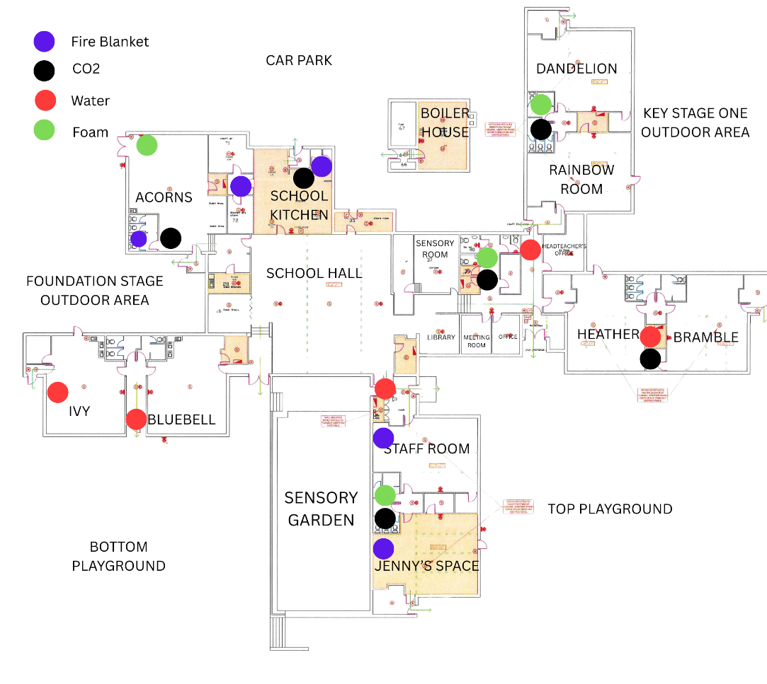

MAINTENANCE OF FIRE FIGHTING EQUIPMENT

A six-monthly check of fire alarms and entrance warning lights will be carried out by the Local Authority.

An Annual inspection of all fire-fighting equipment will be carried out by an external company.

APPENDIX 1
Personal Emergency Evacuation Plan (PEEP)

To be completed by the School’s SENCo

Prepared for: ____________________________________________________________________________
(name of member of staff/student)

Prepared by: ____________________________________________________________________________

In consultation with: ________________________________________________________________(name)

_______________________________________________________ (signature of student/member of staff)

_____________________________________________(name)______________________(parent/guardian)

_____________________________________________(name)______________________________(other)

Valid for Academic Year September ………………….. - July ……………………

Brief description of nature of disability (Mobility/Visual/Hearing/Other):

_______________________________________________________________________________________

Detailed description of assistance required: ___________________________________________________

_______________________________________________________________________________________

Specialist Evacuation Equipment required: YES/NO

Nature: EvacChair
‘Banana’ Board
Other

Helpers required: YES How many _______
NO

Named helpers - See attached timetable (Provided by School)

Date Prepared________________________ Signed____________________________________________

