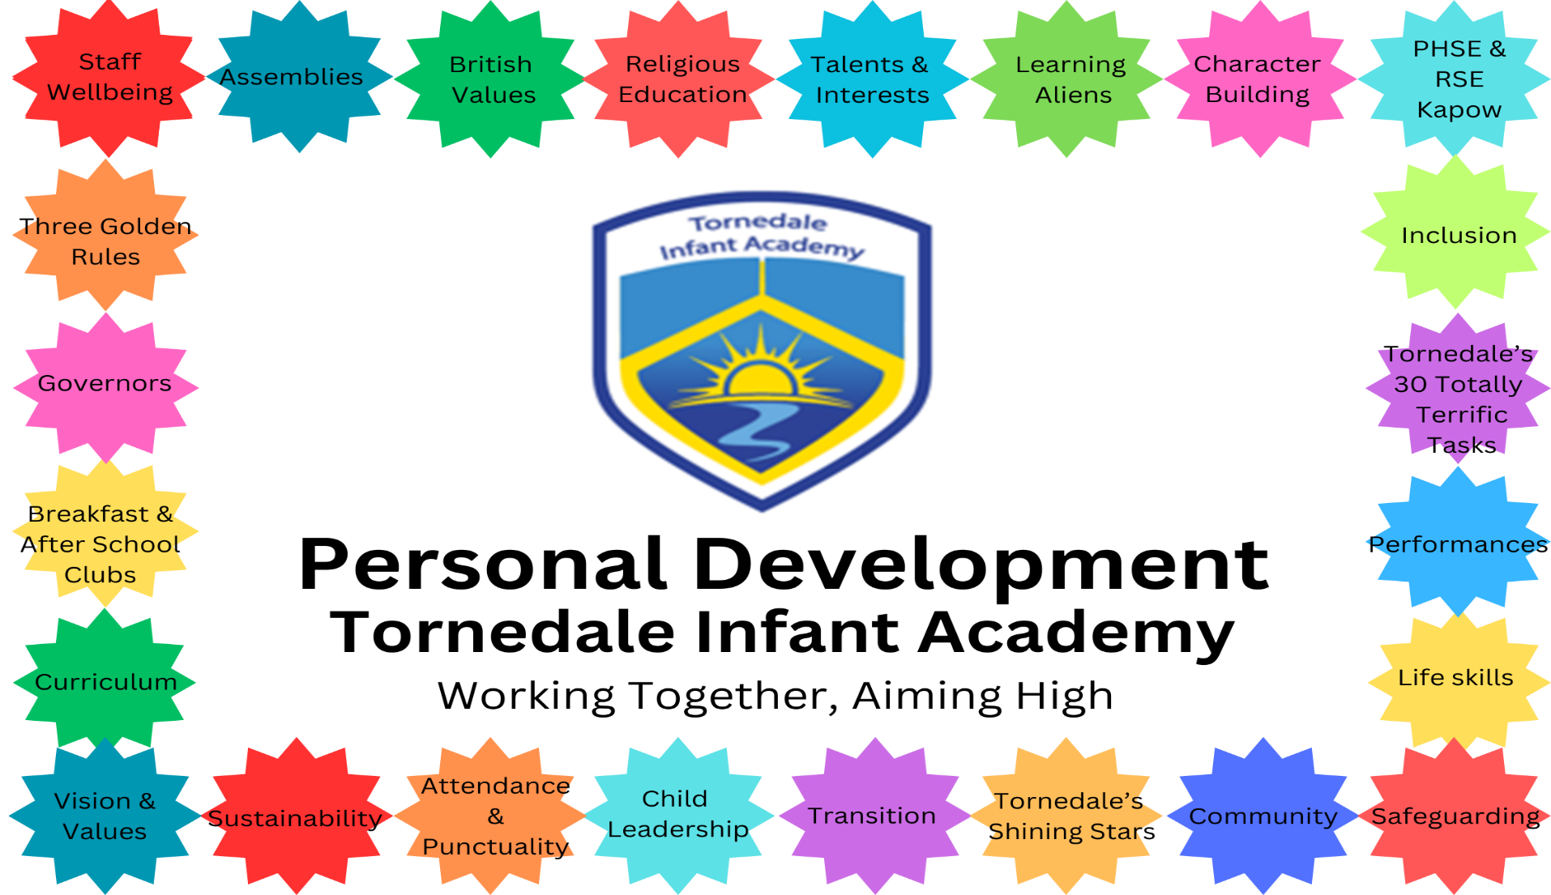

Aspire Curriculum
Intent
Our personal development offer aligns with Leger Academy Trust’s aspirations to have truly great students in truly great schools. We aim to deliver a programme that nurtures ambition, supports, encourages persistence and resilience, inspires all and promotes the value and rewards of hard work.
At Tornedale Infant Academy, it is our intent to provide high quality pastoral support and a well-balanced curriculum that encourages our children to be confident, resilient and independent to prepare them for their future lives. Our three golden rules of; be respectful, be ready and be safe, help them to understand how to be effective citizens in modern Britain. We always strive for equality of opportunity and promote an understanding of the diverse society we live in. Through our extra-curricular opportunities, we aim to nurture our children’s early talents and interests beyond the academic. Our aim is for our children to have an awareness of how to keep mentally and physically healthy, including building healthy relationships. We want our children to have the confidence and knowledge to express their own views, beliefs and opinions, they should question the world around them while still having respect and empathy for the views and feelings of others. It is important that our children understand, appreciate and celebrate the similarities and differences across cultural, religious, ethnic and socio-economic communities. We want our children to be strong, happy and caring individuals who enjoy life and all it has to offer!
Implementation
 | Whole School | FS1 (Nursery) | FS2 (Reception) | Year 1 | Year 2
Curriculum | Kapow – PHSE & RHSE  First Two weeks of every year focus on mental wellbeing  Keeping Healthy  Termly Aspire Events  Kindness week  Children’s Mental Health Week  Online safety day  Sports Day  Bonfire Night  No Pens Day  Walk to School Week | Christmas Performance/ Carol Concert | Kapow:  1. My feelings  2. Special relationships  3. Taking on challenges  4. Listening and following instructions  5. My family and friends  6. My wellbeing  Christmas Performance/ Carol Concert | Kapow:  1.Family and relationships  2. Health and wellbeing  3. Safety and changing body  4. Citizenship  5. Economic wellbeing  6.Transition  Christmas Performance/ Carol Concert | Kapow:  1.Family and relationships  2. Health and wellbeing  3. Safety and changing body  4. Citizenship  5. Economic wellbeing  6.Transition  Christmas Performance/ Carol Concert  Y2 end of year performance
 | RE – Doncaster Agreed Syllabus 2025-2030 supported by Pennine Learning Resources |  | E.1 Which places are special to members of our community? (Pathway 1)  E.2 Why are some objects special? (Pathway 2)  E.3 Who cares for me and how do I help others? (Pathway 3) E.4 Who belongs in my family and community? (Pathway 4)  E.5 How do people celebrate special times? (Pathway 5)  E.6 How do we understand and care for the world? (Pathway 6) | C1.1 What does it mean to belong a community of belief? (Pathway 1)  C1.2 How are symbols used to welcome new life? (Pathway 2)  C1.3 How can we make good choices? (Pathway 3)  C1.4 How and why do some people pray? (Pathway 4)  C1.5 Why are festivals important in a community? (Pathway 5)  C1.6 Which books and stories are important? (Pathway 6)  F1.12 How and why do we care for others? (Pathway 3)  F 1.14 What stories from the Bible have been retold over many years? (Pathway 6)
SMSC
British Values | Assemblies  Golden Rule of ‘Be Respectful’  PHSE and RE curriculum  Relationships policy – Tornedale Shining Stars -Rewards and consequences  Voting for School Council and Playground Leaders  Raising self esteem, teaching right and wrong, strength to say NO
Life Skills | Classroom monitors  Playground Leaders | Transition to FS2 | Transition to Y1 | Transition to Y2 | Transition to new school for Y3 Lunchtime monitors
Character Building | Learning Aliens  Golden Rules  Tornedale Shining Stars  Supporting charities – Operation Christmas Child, Children in Need, Red Nose Day, Rainbow Run
Pupil Voice | School Council  Pupil surveys  Conversations with School Leaders and external visitors  Sustainability Team – 6- 1 from each class  Choosing rewards – attendance, reading at home  Children choose activities they want for golden time |  | School Council Elections | School Council Elections | School Council Elections
Community & Enterprise | Links with Parish Council  Rossington Tigers  Harvest -Festival – donations to local foodbank  Christmas crafts, make and sell  Family Picnic  Christmas and Summer fairs | Sow wild flower seeds in local area  Spring Enterprise project:  Grow and sell sunflower | Make bird feeders for local area  Spring Enterprise project:  Sell Easter cards Debutots programme at Benton House | Run a book swap  Spring Enterprise project:  Sell piece of artwork | Run a school uniform grab & go  Spring Enterprise project:  Make cookies and sell with juice drinks at Craft events.  Letter writing to Parish Council  Performing Carols at Residential Home
Assemblies & Celebration Days | Assembly themes: Celebrating Differences  Staying Safe  British Values  Feelings and Emotions  Special days:  St George’s Day  Christmas  Easter Song/ Poem performance  Eid  Diwali  World Book Day  VE Day | Easter Bonnet & Basket Parade | Easter Bonnet & Basket Parade | Messy Church Christmas Show  Easter Bonnet & Basket Parade | Visit to Rossington Memorial Monument for Remembrance Day  Easter Bonnet & Basket Parade
Visits, Visitors and Special Events | Cast Theatre for pantomime  Reindeer in school  Halloween Disco  African Drummers workshop  Happy Chicks  Network Rail Safety Assembly  Water Safety workshops  NSPCC assembly  Debutots Workshops  Boggledy Book Fair  Alfresco Learning – Outdoor workshops  Toy Day | Local library  Local woods | Seaside  Sundown Adventure  School Nurse- Dental Hygiene | The Deep  Yorkshire Wildlife Park  School Nurse – Safe touch | The Deep  Yorkshire Wildlife Park  School Nurse- Importance of sleep
Nurturing Talents & Interests | After school clubs  Christmas Performances  Xcite multi-skills  Gardening club  Reading club  Craft club  Construction club  Outdoor learning club |  |  | LET sports festivals | LET sports festivals  Reading Buddies with Nursery  Lunchtime Games Leaders  Library monitors
Diversity & Protected Characteristics | Diverse texts  Chinese New Year  No Outsiders Assemblies, 1 per half term |  | No Outsiders – each yr group pick a text to do each term so 3 completed each yr | No Outsiders – each yr group pick a text to do each term so 3 completed each yr | No Outsiders – each yr group pick a text to do each term so 3 completed each yr
Sustainability & Caring For Our Natural World | Litter picking  Composting  Earth Day/ Week | Welly Wednesday- all day | Muddy Monday- half day | Forest Friday – 1 hr at 9.30am, groups with Tree Babies leading | Grounds Maintenance Team – 1 hr, groups assigned each week with TA

Impact
Tornedale’s Thirty Totally Terrific Tasks
We want all our children to achieve these by the time they leave our school.
Visit a place of worship | Build a den | Meet people from different religions or cultures | Perform on stage to an audience | Visit the war memorial for Remembrance day
Learn to bake buns | Visit a library | Go on a bug hunt | Take part in a sporting event | Watch a live performance
Have a picnic | Make crafts with a family member | Visit a farm or zoo | Try food from around the world | Have your art work displayed in an exhibition
Learn by heart and recite a poem or song | Plant a seed and watch it grow | Go litter picking | Visit the seaside | Touch or hold an animal
Fundraise for charity | Read over thirty books | Learn about jobs people do | Watch a chick hatch | Visit the supermarket
Eat something you have grown | Create art with nature | Meet a reindeer | Have the opportunity to take part in an after school club | Get an achievers certificate

Assessment for RE & PHSE
Pupil & Parent Surveys

